[DevOps automation helps bring software to market quicker than ever before, but it can also introduce crippling vulnerabilities just as fast.](https://www.bing.com/ck/a?!&&p=4fa3dffe8a02ca0bJmltdHM9MTY2MDA4OTYwMCZpZ3VpZD0zODMxN2I1NS1kZmQwLTYxZDMtM2NmYy02YmI2ZGViNDYwOTUmaW5zaWQ9NTYwMQ&ptn=3&hsh=3&fclid=38317b55-dfd0-61d3-3cfc-6bb6deb46095&u=a1aHR0cHM6Ly9lbnRlcnByaXNlcnNwcm9qZWN0LmNvbS9hcnRpY2xlLzIwMjAvMS9kZXZvcHMtZW5naW5lZXItaW50ZXJ2aWV3LXF1ZXN0aW9ucy0yMDIwIzp-OnRleHQ9RGV2T3BzJTIwYXV0b21hdGlvbiUyMGhlbHBzJTIwYnJpbmclMjBzb2Z0d2FyZSxjcmlwcGxpbmclMjB2dWxuZXJhYmlsaXRpZXMlMjBqdXN0JTIwYXMlMjBmYXN0Lg&ntb=1" \t "_blank)

DevOps is a set of practices that combines software development (Dev) and IT operations (Ops). It aims to shorten the systems development life cycle and provide continuous delivery with high software quality. DevOps is complementary with Agile software development; several DevOps aspects came from the Agile methodology.

[7 top DevOps engineer interview questions for 2020 | The Enterprisers Project](https://enterprisersproject.com/article/2020/1/devops-engineer-interview-questions-2020#:~:text=DevOps%20automation%20helps%20bring%20software,crippling%20vulnerabilities%20just%20as%20fast.)

[The Complete DevOps Certifications Guide for 2022 – BMC Software | Blogs](https://www.bmc.com/blogs/devops-certifications/)

[7 skills CIOs say are core to their jobs | The Enterprisers Project](https://enterprisersproject.com/article/2022/8/7-skills-cios-say-are-core-their-jobs)

[Beyond innovation: Cross-functional skills for IT leaders | The Enterprisers Project](https://enterprisersproject.com/article/2022/8/beyond-innovation-cross-functional-skills-it-leaders)

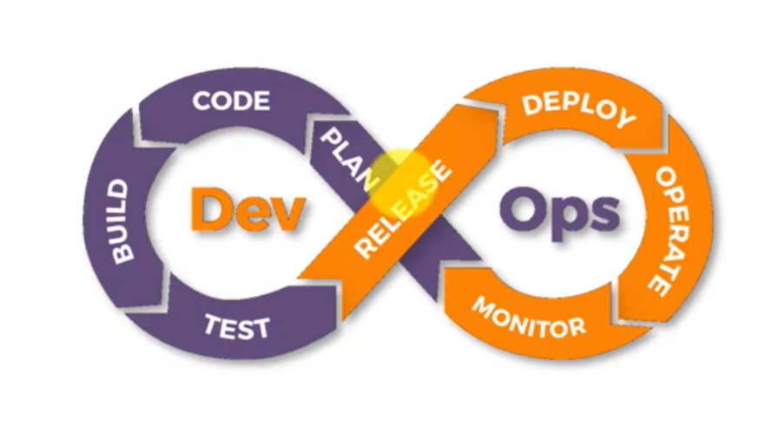

1. CVCS – Centralized Version Control system

Tools include SVN – Subversion and Helixcore

1. DVCS – Distributed version control system.GIT is also known as source control management (SCM)

Tools include – Git, Perforce,Mercurial

1. Github is a hosting platform where one can collaborate with others one ones Git repositories.It is also known as the remote repository

Common Commands in GIT

* Create your working directory
* Initialize the working directory so that GIT to create a **local repository** and enable can track changes. Commond to use is **git init**
* TO know the status of directory and files in your local repository is **git status**
* Add files to the stage area in your local repository in GIT using the git add . ( for all files in your local directory) or mention each file name that you want to add to the staging area
* Save the file to git using the command git commit -m “ type message”
* TO discard the change that you made to a file before in GIT, use the commant git checkout -- <filename>
* To sync your local repository with remote repository, use the command - git remote add origin “< remote githut url>” OR use the command git clone <remote url>
* After syncing your local repository with your remote repository, then it is time to push or pull
  + 1. To push files from your local repository to the remote, type git push origin <branch -name > in this case the branch name is the master branch, so the syntax would be git push origin master
    2. To pull – git pull origin master. If you want to pull all the changes made to the remote repository, you can use git pull < remote url>? . This only works from initialized working directory or already cloned remote repository on your local machine.
  + TO add branch to the repository which is to facilitate multiple developer working on the same source code, use the command git branch <branchname>
  + To delete the branch use git branch -D <branchname>
  + TO switch between the branch and master , use the command git chechout <branchname>
  + Git log command helps you to see the history of commands done on your repository
  + To save a file ( already staged file) without committing it to either the master or the branch, type git stash
  + For unstacked or yet to be tracked (ubtracked) files , use git stash -u
  + TO activate stash files in the branch or master , type git stash pop

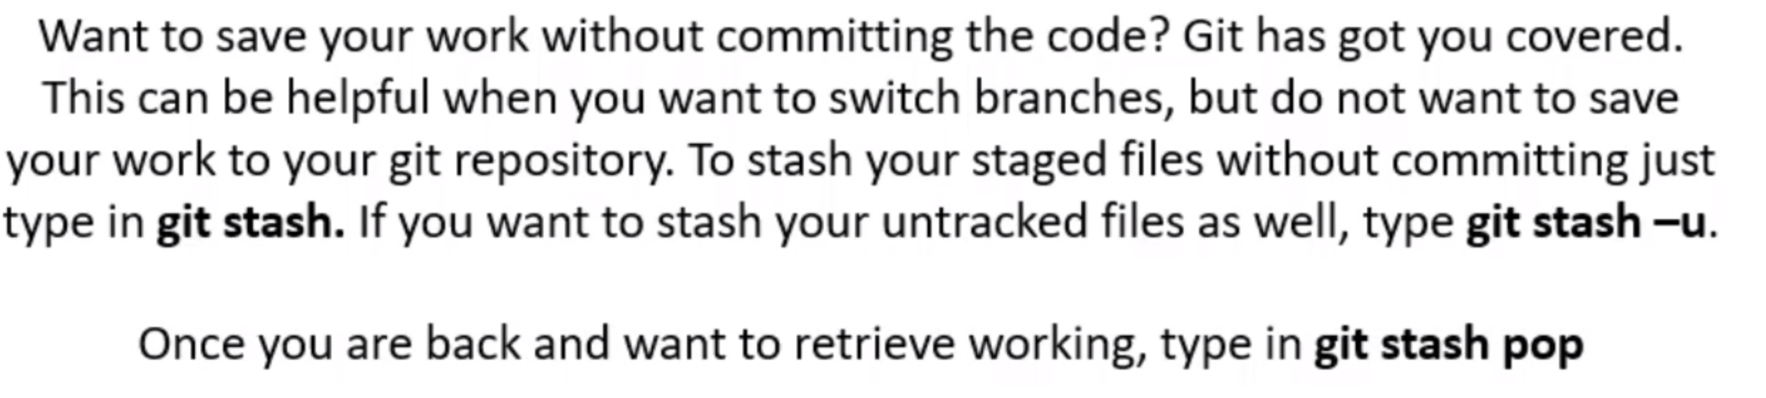

[How To Install Git Bash On Windows 10 - Bing video](https://www.bing.com/videos/search?q=git+bash&docid=608034019404368133&mid=5BAB493F2E3B4B13B9745BAB493F2E3B4B13B974&view=detail&FORM=VIRE)

* + To revert to previous changes/version after committing a file ,you type git revert <commit id>

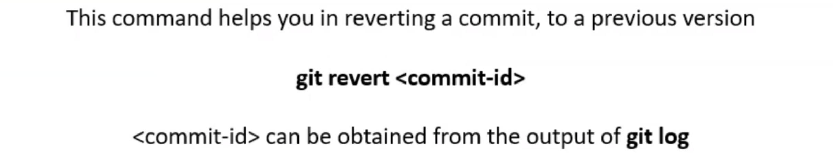

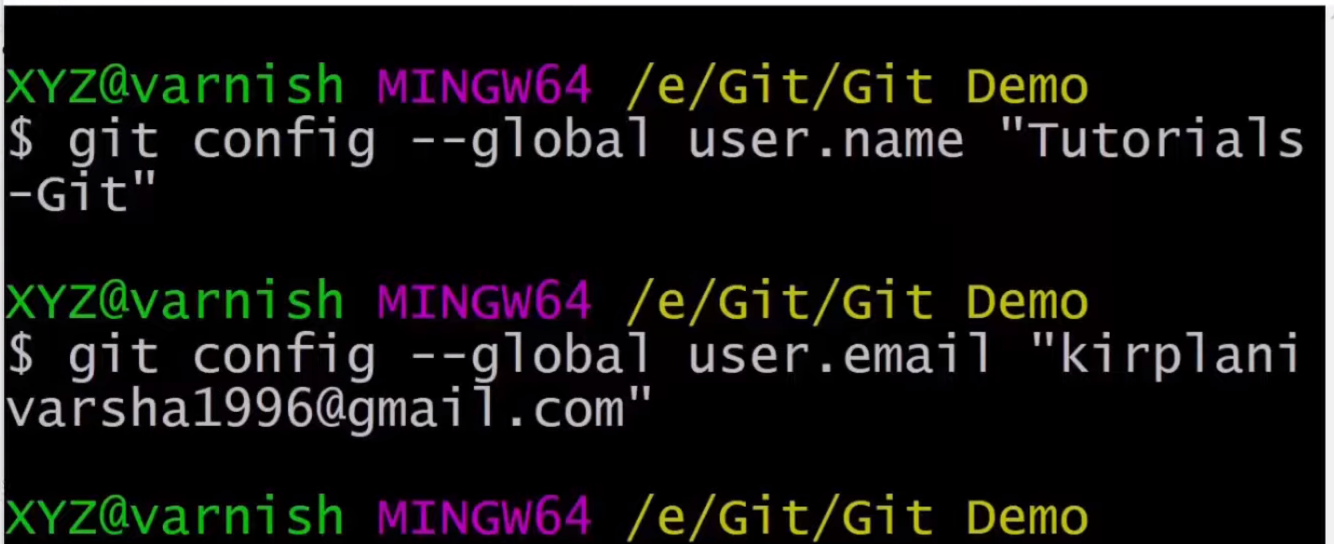

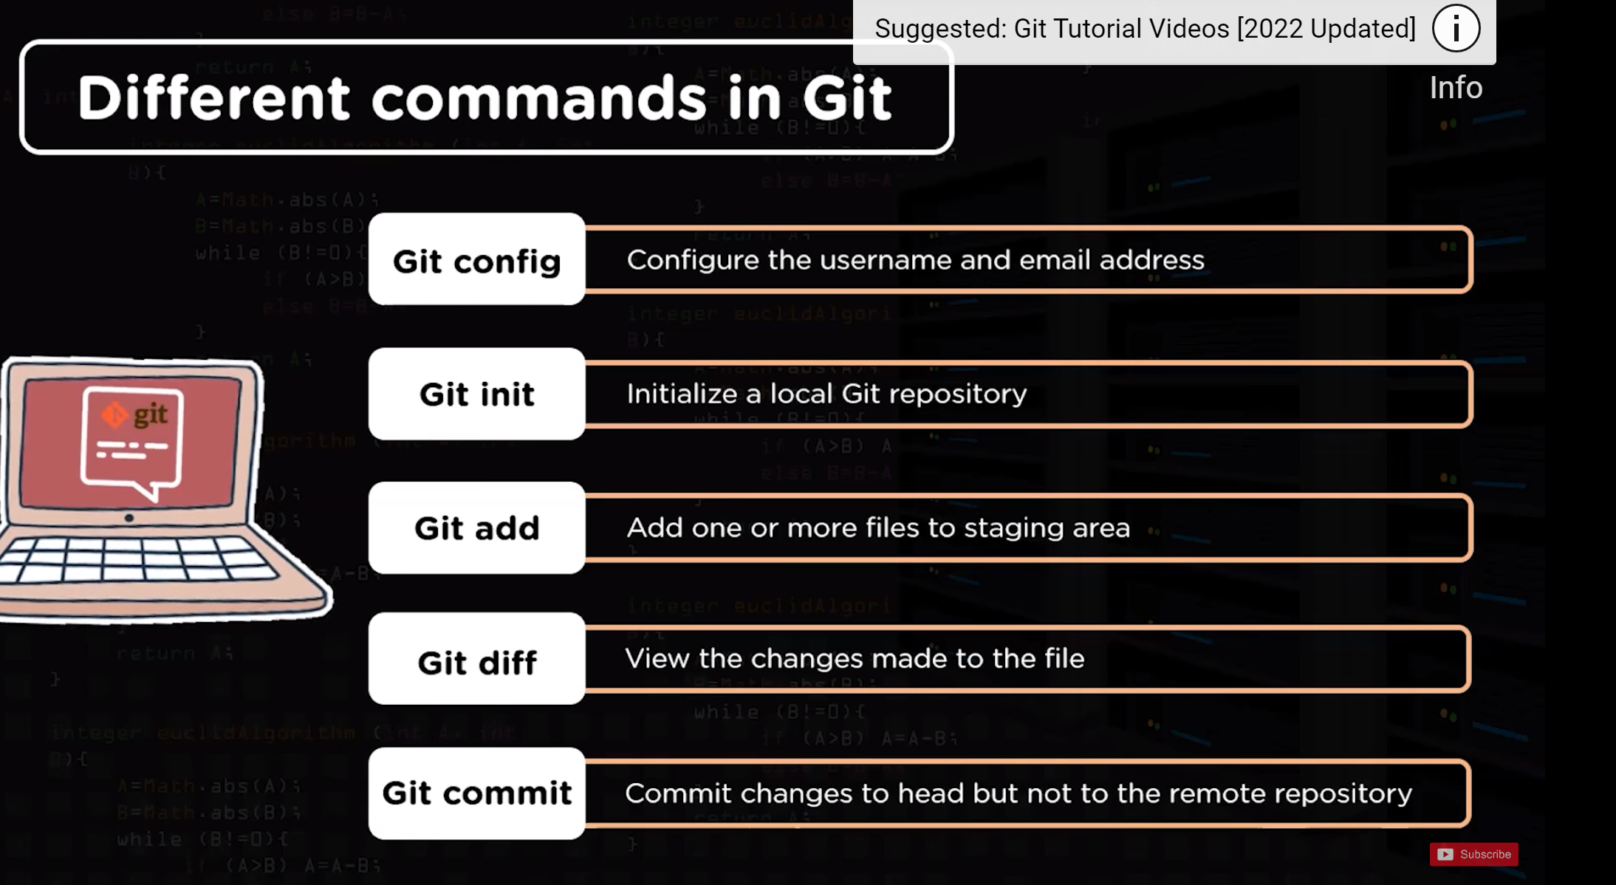

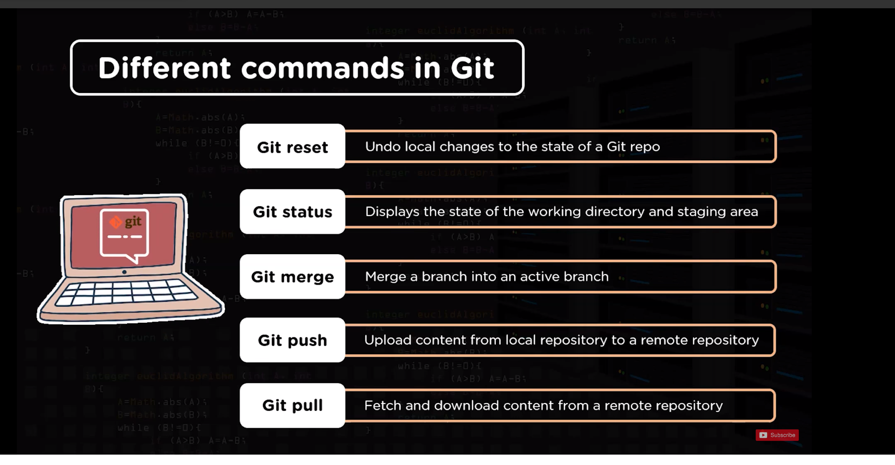

Git log –graph –pretty=oneline

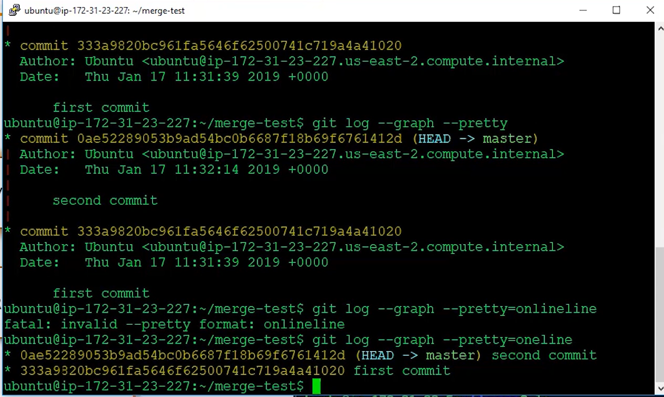

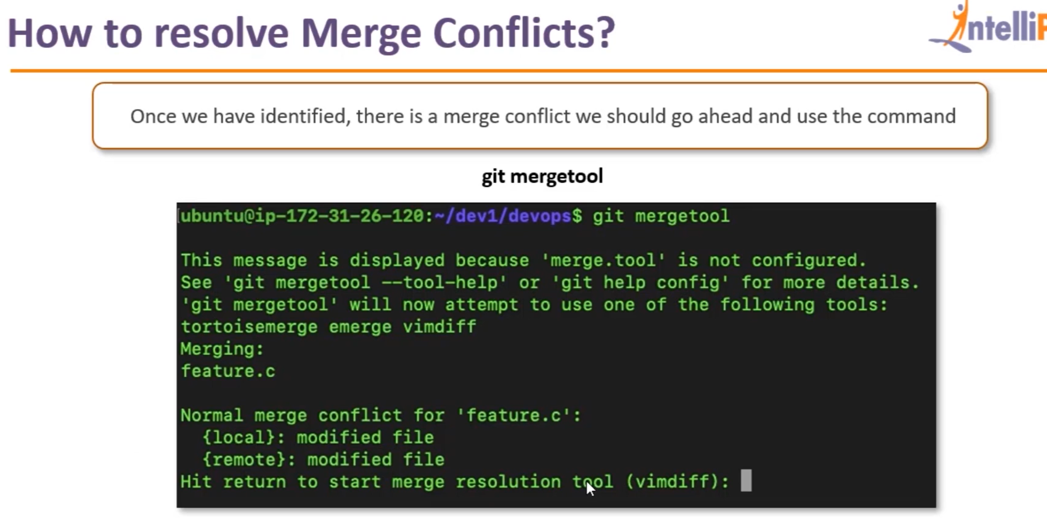

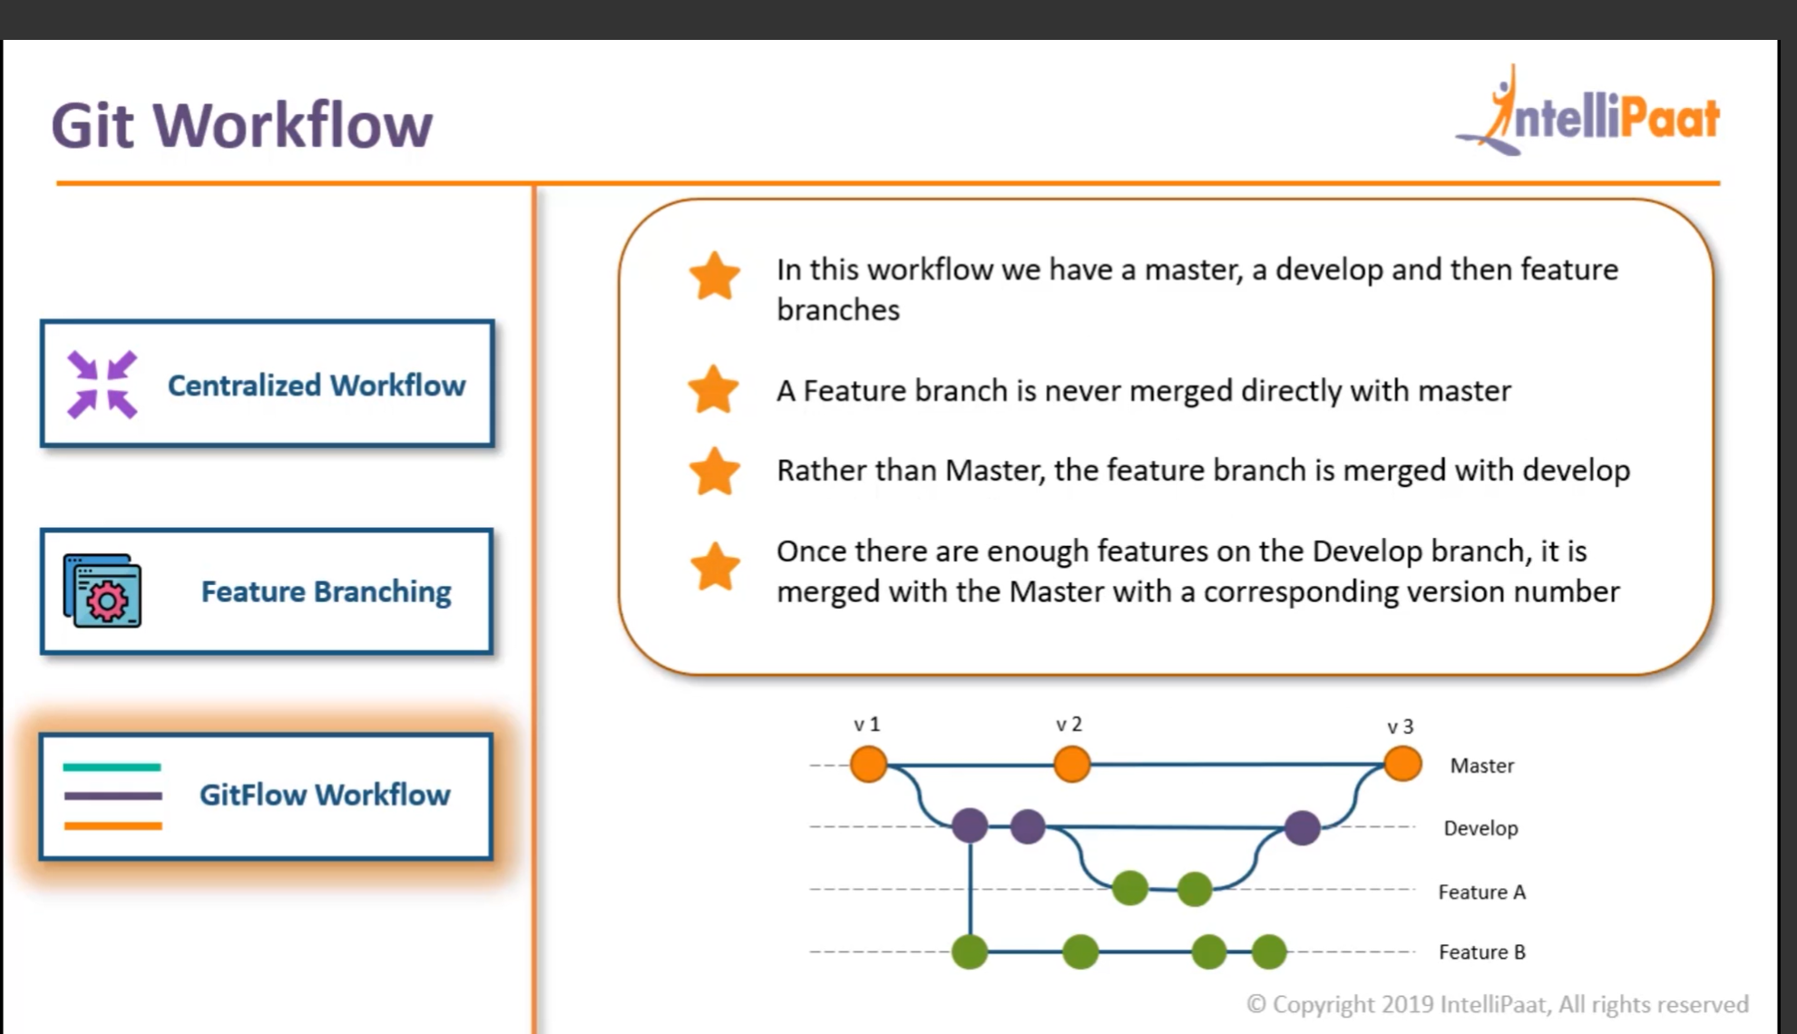

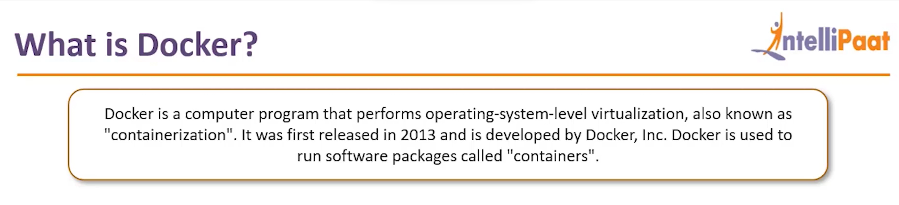

A container does not have a kernel in place but rely on the undelying operating system where it is installed. They just need the minimum binary or lib required to run hence reason why it is light

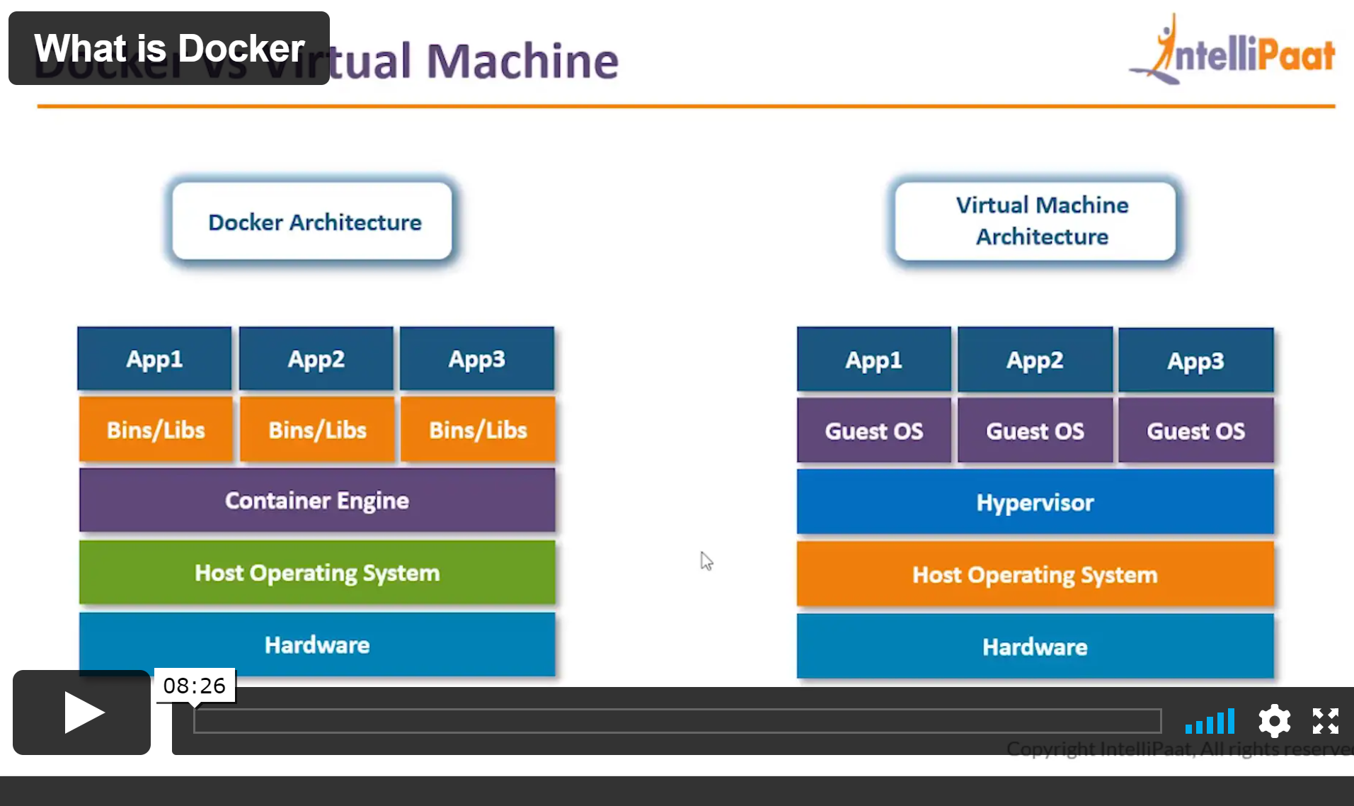

[How To Install Docker on Windows? A Step-by-Step Guide [Updated] (simplilearn.com)](https://www.simplilearn.com/tutorials/docker-tutorial/install-docker-on-windows#stepbystep_docker_installation_on_windows)

[Docker is an OS-level](https://www.simplilearn.com/tutorials/docker-tutorial/what-is-docker) virtualization software platform that helps users in building and managing applications in the Docker environment with all its library dependencies.